Results for p as a response variable, and 16 predictor variable(s).

n: 65535 r: 0.856 r²: 0.732 r²adj: 0.732 F: 11191.846 P: 0

Akaike's Information Criterion (AICc): -121009.972

Variable Coeff. Std Coeff. VIF Std Error t P Value

Constant 2.464 0 0 0.015 159.645 <.001

bio_15 -0.005 -0.222 6.558 <.001 -42.95 <.001

bio_19 -0.011 -0.712 4.95 <.001 -158.316 <.001

bio_3 -0.009 -0.148 2.991 <.001 -42.196 <.001

bio_4 <.001 -0.917 4.542 <.001 -212.826 0

CST <.001 -0.003 1.092 <.001 -1.588 0.112

HII 0.005 0.144 1.781 <.001 53.31 0

LUCC -0.003 -0.151 1.181 <.001 -68.759 <.001

PC -38.156 -0.074 1.005 1.041 -36.667 <.001

s01 1.607 0.262 1.876 0.017 94.558 <.001

s02 -1.929 -0.301 1.633 0.017 -116.534 0

s03 -1.653 -0.258 1.904 0.018 -92.317 <.001

s04 -0.22 -0.034 1.335 0.015 -14.725 <.001

s05 -0.833 -0.127 1.201 0.014 -57.519 0

s06 2.133 0.332 1.113 0.014 155.805 <.001

s07 -1.635 -0.254 1.117 0.014 -119.08 <.001

s08 0.187 0.029 1.275 0.015 12.719 <.001

Condition Number: 5.788

Mean of Correlation Matrix: 0.117

1st Eigenvalue divided by m: 0.18

Descriptive Statistics:

p Estimated Residuals

Min 0.004 -0.564 -0.305

Max 0.754 0.645 0.921

Mean 0.224 0.224 <.001

Std.Dev. 0.186 0.159 0.096

Skewness 0.283 0.022 0.156

Kurtosis-495546500.677 -495546120.532 -495552738.162

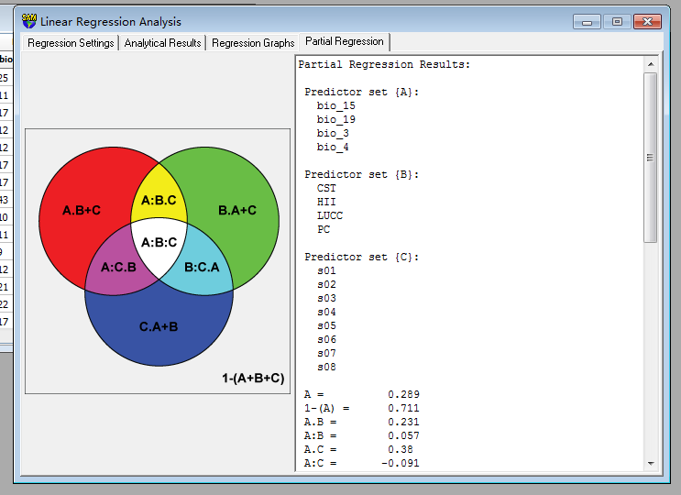

Partial Regression Results:

Predictor set {A}:

bio_15

bio_19

bio_3

bio_4

Predictor set {B}:

CST

HII

LUCC

PC

Predictor set {C}:

s01

s02

s03

s04

s05

s06

s07

s08

A = 0.289

1-(A) = 0.711

A.B = 0.231

A:B = 0.057

A.C = 0.38

A:C = -0.091

A.B+C = 0.226 a

A:B+C = 0.063

B = 0.104

1-(B) = 0.896

B.A = 0.046

B:A = 0.057

B.C = 0.197

B:C = -0.093

B.A+C = 0.043 b

B:A+C = 0.061

C = 0.309

1-(C) = 0.691

C.A = 0.4

C:A = -0.091

C.B = 0.402

C:B = -0.093

C.A+B = 0.397 c

C:A+B = -0.088

A+B = 0.335

1-(A+B) = 0.665

A+B.C = 0.423

A+B:C = -0.088

A+C = 0.689

1-(A+C) = 0.311

A+C.B = 0.628

A+C:B = 0.061

B+C = 0.506

1-(B+C) = 0.494

B+C.A = 0.444

B+C:A = 0.063

A+B+C = 0.732

1-(A+B+C) = 0.268

A:B.C = 0.154 d

A:C.B = 0.005 e

B:C.A = 0.003 f

A:B:C = -0.096